(Approx. 1,111 words)

Musings of an Apple Tyro
By Lorrin R. Garson, Potomac Area Technology and Computer Society
February 2017 issue, PATACS Posts
www.patacs.org
newslettercolumnist (at) patacs.org

Condition of Your MacBook Battery
When is it time to replace the battery in your MacBook? A clue is when the computer seems to be running an increasingly shorter length of time when powered by the battery. But more information is available using the procedure described below.
- Holding down the Option key, left-click on Apple icon, which is located on the far left of the Finder menu (far upper left of the display). Select “System information”.
- In the pane on the left in the “Hardware” section, left-click on “Power”.
- In the pane on the right, scroll to “Battery information”.
- In the “Health Information” section, note (a) Cycle count and (b) Condition”.
- See Figure 1 below as an example. Note the “Cycle count” is 152 and the “Condition” of the battery is “Normal”.

Generally, the health of the battery is largely dependent on the number of times the battery has been recharged (Cycle count). Depending on the model of MacBook, the maximum number of recharge cycles varies from 300 to 1000 at which point Apple deems the battery to have been consumed and should be replaced. See http://apple.co/2g0bxeT for the maximum recharge cycles for your model of MacBook.

Of course, the battery may still be functional although the length of time the MacBook can run on the battery may be considerably less than when the computer was new.
Attention also needs to be given to the reported condition of the battery. The following information is from http://cnet.co/2h83UrO.
- Normal: The battery is functioning normally.
- Replace Soon: The battery is functioning normally but holds less charge than it did when it was new.
- Replace Now: The battery is functioning normally but holds significantly less charge than it did when it was new. You can continue to use the battery until you replace it without harming your computer.
- Service Battery: The battery isn't functioning normally, and you may or may not notice a change in its behavior or the amount of charge it holds. Take your computer in for service. You can continue to use your battery before it's checked without harming your computer.

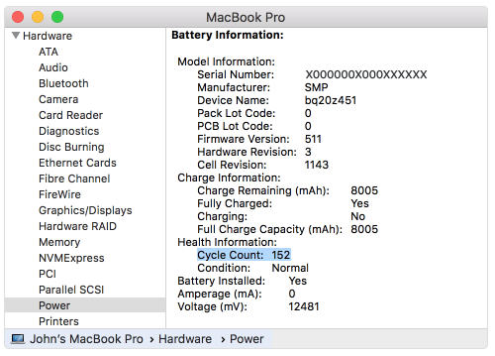
Figure 1: Battery Health

AirDrop Seemingly More Stable
AirDrop is a mechanism introduced in July 2011 for transferring files between and among Apple computers and iOS devices (see http://bit.ly/2hoHcuY. My personal experience is that AirDrop has been a hit-and-miss affair—sometimes it works, sometimes it doesn’t. However, with the introduction of macOS Sierra, my experience is that between Mac computers, AirDrop is now stable and functional. I haven’t tried it with my iOS devices yet. See http://apple.co/2g08u6s to use AirDrop with iOS devices and http://apple.co/2gpxfK5 for transferring content among macOS and iOS.

Two Quirks with PowerPoint on Mac Computers
Running Microsoft’s PowerPoint for Mac [version 15.28 (161115), i.e., Office 365] with macOS Sierra (version 10.12.1) exhibits some strange behavior. (1) The hypertext links from graphic objects of PDF files exported from PowerPoint do not work, although they function as expected in the corresponding PowerPoint (.pptx) file. (2) If you invoke Siri when PowerPoint is running in Presenter View, the audio output from Siri works as expected, and the visual output from Siri is displayed on the computer screen, but the visual output from Siri does not display with a Dell 2400MP projector. This is not a problem if PowerPoint is running in Slide Show mode. Obscure? Yes, but these kinds of things can drive you crazy!

Apple’s Differential Privacy
Is “differential privacy” just an emollient to calm our fears of about our private information being exploited? Not so. To quote from Wikipedia (http://bit.ly/290eZms) “…differential privacy aims to provide means to maximize the accuracy of queries from statistical databases with minimizing the chances of identifying its records.” In other words, a technology for organizations to extract as much information as possible from the data they collect from us without identifying the specific source of that information—namely us as individuals. Apple has actively embraced this technology to protect its customers’ privacy. See http://bit.ly/290OxtB and http://bit.ly/293gO65. For a scholarly paper entitled “The Algorithmic Foundations of Differential Privacy” see http://bit.ly/298cIei.devices.

Apple Doesn’t Benefit from Samsung’s Woes
There has been much speculation that Apple would benefit from Samsung’s recall of their Galaxy Note 7 cell phones. However, as shown in the table below, it seems that Chinese brands are the winners, not Apple.
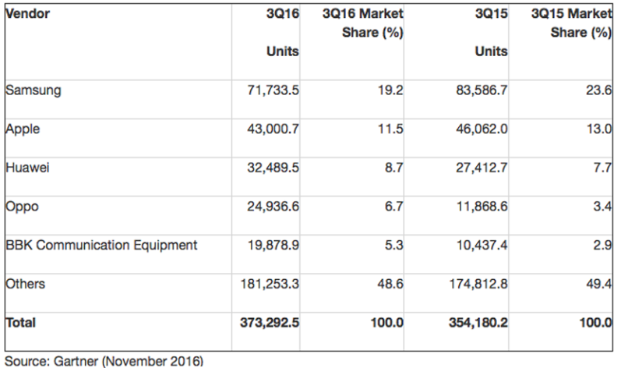

Apple’s Policy for Fixing iPhone 6 Plus
Engadget reports that Apple will fix your iPhone 6 Plus that has “touch disease” for $149. Apparently, Apple believes this condition is caused by owners dropping their phones. See http://engt.co/2gDuGqR. However, there is a report that the problem is the consequence of a design defect. See http://bit.ly/2gDCs4b. By the time you read this more information will be known about this problem and its cause.

Apple Saves iPhone History
From http://bit.ly/2g7CnmR, “Apple saves up to four months of a user’s call history whenever they are using iCloud Drive, according to Elcomsoft” (also see https://www.elcomsoft.com/). The call history saved to iCloud keeps detailed information including phone numbers, dates, times of day the calls were made or received, and duration of calls, as first reported in http://bit.ly/2fP3thW. Data for missed and ignored calls is also synced. In iOS 10, this synced data includes call data from VoIP apps that use Apple’s new CallKit framework. If you are distressed by this the only solution at this time seems to be to not use iCloud Drive.

Miscellaneous Interesting Items
- See http://techtalkamerica.com for a Web site that offers free and for fee classes on Apple issues and products. David A. Cox is the founder of this service and is generally well regarded in Apple circles.
- Prices of SSDs are expected to rise next year, so if you are thinking of buying one (or more), purchasing sooner rather than later might be prudent. See http://bit.ly/2hcv549.
- PCWorld lauds the new MacBook Pro with Touch Bar, see http://bit.ly/2g7ou9M.
- See http://bit.ly/2h85jyC for a useful source for information for Apple computer users from Lifewire. Lifewire also provides extensive information for Windows and Linux users and other areas of technology. See https://www.lifewire.com.
- Want to be able to track your stuff? See https://www.thetrackr.com/ for TrackR devices.
- See http://bit.ly/2g4L6X8 for “3 encryption tools for Linux that will keep your data save”.
- See http://bit.ly/2gV7t1g for “Fedora 25 makes Linux easy enough for anyone to try”. Give it a whirl.
- Self-driving cars are coming! See http://bit.ly/2g7jD8t for “Intel plans to make the Core i7 the brains behind self-driving cars.

